# Install Ubuntu 20.04 LTS Desktop

To begin the installation, click **Install Ubuntu**.

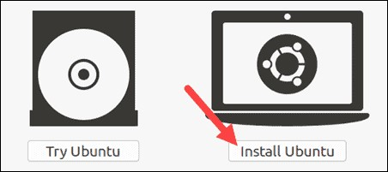

## Choose Keyboard Layout

By default, the system will select English and English.

If you have a non-standard keyboard, you can select it in the list. Alternately, click **Detect Keyboard** **Layout** and the system will automatically choose your keyboard. If you need to test your keyboard, use the labeled field.

When you’re ready, click **Continue**.

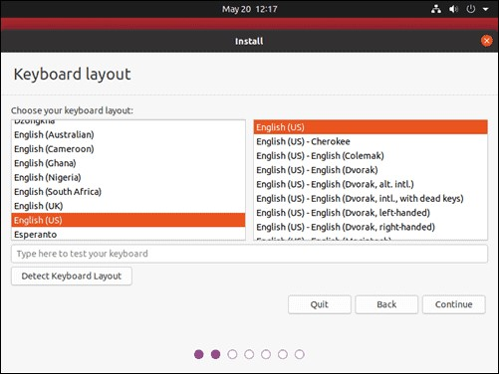

## Choose Starting Applications

* **Normal Installation** – This is the full Ubuntu Desktop experience, with office software, games, and media players.
* **Minimal Installation –** Choose this to save disk space, especially if you won’t be using media players or productivity software.

You’ll also be asked to confirm other options:

* **Download updates while installing Ubuntu** – This does the work of downloading large package files during the installation. Once the installation finishes, the packages will be ready to apply as updates.
* **Install third-party software for graphics and Wi-Fi hardware and additional media formats –** Some hardware, like graphics cards and wi-fi cards, do not have open-source driver support. Also, some media formats, such as .wmv, do not fall under the GPL license. If you need support for these, you’ll need to agree to additional terms of use.

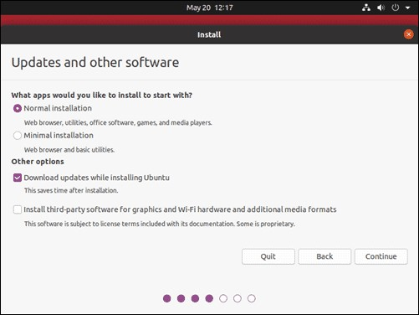

## Disk Partitioning

Next, you’ll be presented with an **Installation Type** dialog. You can wipe the hard drive clean prior to installing Ubuntu by clicking **Erase disk and install Ubuntu**. If you go this route, skip ahead to the next step.

Advanced users may want to edit **Advanced Features**. Use this to specify your own disk partitions or set other advanced options:

* **Use LVM with the new Ubuntu installation:** LVM stands for *Logical Volume Management*. This is a tool for dynamically managing different virtual drives on your system. It’s much like an enhanced version of the **gparted** tool.
* Encrypt the new Ubuntu installation for security: This will encrypt the drive’s contents. You’ll choose a security key, which will be required to decrypt and use the drive.
* Experimental: Erase disk and use ZFS: ZFS refers to Zettabyte File System, but it has grown into a hybrid file system and volume manager. Since it’s still being tested, avoid this setting on missioncritical production systems.

If you’d rather create your own hard drive partitions, click **Something Else**.

The next screen will allow you to create your own partition table and logical drives. This lets you divide a physical hard drive into different partitions. The operating system sees partitions as individual drives.

**Note**: Some users create their **/home** directory on a separate partition. If the operating system needs to be reinstalled, the partition with the /home directory is unaffected.

Click **Continue** to apply your changes to the drive partitions.

You’ll be asked to **Write changes to disks?** None of the options you’ve selected are permanent until you click **Continue** on this screen. Click **Continue** to proceed.

## Select Time Zone

Once the system formats the disk partitions, the installer will ask **Where are you?**

Type the nearest large city into the box, and the system will **set your local time zone**.

Click **Continue**.

**Note**: It’s always possible to change the timezone on Ubuntu at a later point in time.

## Create User Account

Next, you’ll need to configure a user account. Fill in the following fields:

* **Name:** Your actual name.
* **Computer name:** This is the hostname or network name.
* **Username:** The user account name you want to use.
* **Password:** Enter and confirm a strong password – the installer will automatically evaluate your password strength.
* **Log in automatically:** This is not recommended for publicly accessible servers.
* **Require my password to log in:** This is recommended for publicly accessible servers.

Click **Continue** to install Ubuntu.

Once the installer finishes, remove the Ubuntu installation media. You’ll be prompted to **Restart Now**.

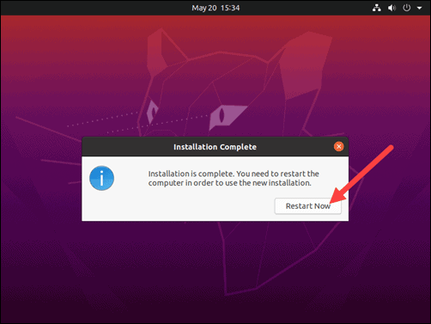

The system should boot into your fresh install of Ubuntu 20.04.